

Adapt 2010 Programme
OneTouch System Solution Architecture

Document History Table
Version | Author | Date Created | Changes Summary
0.1 (Draft) | Nitin Mahajan | 20th May 2008 | Initial version
0.2 (Draft) | Nitin Mahajan | 06th June 2008 | Daxtra-Broadbean integration details
0.3 (Draft) | Nitin Mahajan, Balu Herbert | 20th June 2008 | Updated Architecture overview
1.0 | Nitin Mahajan, Balu Herbert | 09th July 2008 | Issue for AMB sign-off
1.1 | Nitin Mahajan, Balu Herbert | 14th August 2008 | Updated Component Descriptions
2.0 | Nitin Mahajan, Balu Herbert | 23rd Oct 2008 | Updates for DC4 Release
2.1 | Nitin Mahajan | 17th Dec 2009 | Updates for DC5 Release
2.2 | Nitin Mahajan, Balu Herbert | 1st Feb 2009 | Updates for DC6 release
2.3 | Nitin Mahajan, Balu Herbert | 1st March 2009 | Updates for DC7 release
2.4 | Nitin Mahajan | 18th March 2009 | Updates for DC8 release
2.5 | Nitin Mahajan | 03rd June 2009 | Updates for DC9 release
3.0 | Balu Herbert | 14th July 2009 | Updates for DC10 release
3.1 | Nitin Mahajan | 25th August 2009 | Updates DC11 Release
3.2 | Nitin Mahajan | 1st Sep 2009 | Updates for DC12 Release
3.3 | Nitin Mahajan | 17th Oct 2009 | Updates for DC13 Release
3.4 | Nitin Mahajan | 21st Nov 2009 | Updates for DC14 Release
3.5 | Nitin Mahajan | 9th Jan 2009 | Updates for DC15 Release
3.6 (Draft) | Nitin Mahajan | 7th Feb | Updates for DC16 Release

Reviewer Table
Title | Name | Dated | Approval Y/N | Signature
Project Manager | Mark Whenham | 08/07/2008 | Y
Hays Design Authority | Eric Moore
Proveho Solution Architect | Jon Buckham

Approval Table
Title | Name | Dated | Approval Y/N | Signature
Programme Director | Manoj Agarwal

Contents

1 Introduction 3
1.1 Background 3
1.2 Purpose 3
1.3 Scope 3
1.4 Intended Audience 3
1.5 References 3
2 Architecture Overview 5
2.1 Architectural Goals 5
2.2 Context Model 5
3 Application Architecture 7
3.1 Reference Model 7
3.2 Logical View 8
4 Application Components and Integrations 9
4.1 Component List 10
4.1.1 Hays Hosted Components 10
4.1.2 3rd Party Components 15
4.2 Component Interaction Points 15
4.3 Integration Mechanism 19
4.4 Address Lookup Integration (C14) 19
4.5 CV Parsing Service Integration (C56) 21
4.6 Back Office Integration Component (C60) 22
4.6.1 Global Back Office Integration 22
4.6.2 JD Edwards to PeopleSoft transition (UK only) 26
4.6.3 PeopleSoft Interface 32
4.7 Search – Google Search Appliance (C58) 37
4.8 Front Office Integration Service (C57) 38
4.8.1 Google search Integration (Candidate Search) 38
4.8.2 Google search Integration (Candidate Update – XML feeds to GSA) 40
4.8.3 Data Enrichment Service 42
4.8.4 Google Maps Integration Service 43
4.8.5 Organisation Hierarchy Service 43
4.9 Document Management Integration (C65/C66) 44
4.10 Web Uploader Service (C64) 45
4.11 Operational Reporting Component (C62) 46
4.12 Contracts Portal Component (C62) 47
4.13 HPI Integration Component (C62) 48
4.14 Candidate Registration Service 49
5 Infrastructure Architecture 50
5.1 Logical Deployment Model 50
5.2 Logical Deployment Components List 51
6 Security 53

Introduction

Background
The key business objective of the Adapt 2010 programme is to renew the technology alongside a business change to streamline the Front Office Operations. As part of the Adapt 2010 programme, a replacement front office system “OneTouch” has been developed. The global system design for OneTouch aims to:
- Make Hays easier to work for and easier to work with
- Deliver a standard front office system design globally
- Utilise internet tools to improve productivity
- Establish one database per country/region

OneTouch uses Bond Adapt v11 as the core engine.

Purpose
The purpose of this document is to present a conceptual and logical view of the solution architecture for OneTouch global system. This also includes the identification and definition of the interfaces required with the supporting front-office and back-office systems.

Scope
The scope of this document is limited to Global Solution Architecture of OneTouch system. This includes:
- Application Architecture
- Application Components and Integrations
- Logical Deployment Model

In addition, it also covers the high level design of UK specific implementations for the integration interfaces defined by the global architecture. Any other country/region specific localisations are outside the scope of this document. Details of architectural components which are included or excluded for a specific country/region implementation are also outside the scope of this document.

Where relevant, the document covers high level design of individual components. However, the detailed design of components and integration interface implementations is outside the scope of this document and is captured separately. The Physical deployment architecture is also outside the scope of this document.

Intended Audience
The document is intended for all members of Adapt 2010 programme team. It will also be of interest to other stakeholders in the Adapt 2010 programme, in particular the Proveho programme stream and the Hays Web team.

References
 | Document | Location | Version
1 | Hays Architecture Decisions | SharePoint–DesignAuthority–EnterpriseArchitecture | 1.1
2 | Hays Architectural Principles | SharePoint–DesignAuthority–EnterpriseArchitecture | 0.2
3 | Proveho Solution Architecture | O:\Project Proveho\Phase 2\Process and Applications | Various
4 | Adapt Architectural Decisions | http://hsrdk2k7sp1/haysit/pmo/adapt/InterfaceDesignBuild/03%20Design/Forms/AllItems.aspx?RootFolder=http%3a%2f%2fhsrdk2k7sp1%2fhaysit%2fpmo%2fadapt%2fInterfaceDesignBuild%2f03%20Design%2fArchitectural%20Assumptions&FolderCTID=0x012000A20349157A9D1B4AA937FEC20F2FE976 | Various

Architecture Overview

Architectural Goals

- Scalability, performance and availability
The architecture must be able to deliver systems that are able to operate 24x7 and is capable of scaling to a very large number of users.
- Consolidation
The architecture should allow for a system which can be deployed globally removing the need for local silos
- Security
The architecture should provide a security platform which is secure enough to handle financial and sensitive information.
- Interoperability
It must be possible for non-Adapt clients to make use of the services offered by the Adapt system. Also, it must be possible for Adapt system to make use of services provided by other systems.
- Configurability
The architecture should be able to deliver system which is implemented through configuration, with the minimum of coding effort.
- Flexibility
It should be possible to modify the implementation of Business Processes with minimal impact on the system.
- Use of standard technologies
In the interests of being as “open” as possible, standard technologies will be used in preference to “proprietary” techniques. Defined industry standards will be used as far as possible for integration and inter-operability choices.
- Simple upgrade path between product versions
By adopting a loosely couple architecture, the aim would be to simply upgrade of software components.
- “Plugability”
Through the use of well defined interfaces on components/systems, it should be possible to remove a component and replace it with another implementation
- Minimise dependency on Adapt v11
To overcome the technical constraints imposed by Adapt v11 architecture, an architectural decision has been taken to minimise the dependency on Adapt v11

Context Model

The figure below provides an overall view of the architecture at a conceptual level. The aim is to highlight the system and sub-systems that make up the overall Adapt v11 business solution and identify the interaction with external systems.
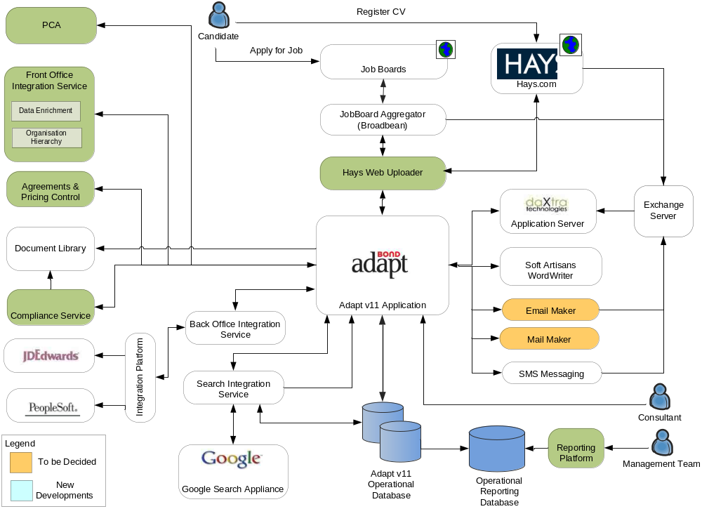
Figure 1 – OneTouch Global System Context Model

Application Architecture
The purpose of this section is to define the architectural reference model for OneTouch Application and the logical model which implements the reference model. A High level design is also included for completeness. The detailed design is outside the scope of this document and will be documented separately.

Reference Model
The figure below summarises the reference model for OneTouch system design. The reference model will be applicable to both the global system design and the application localisation.

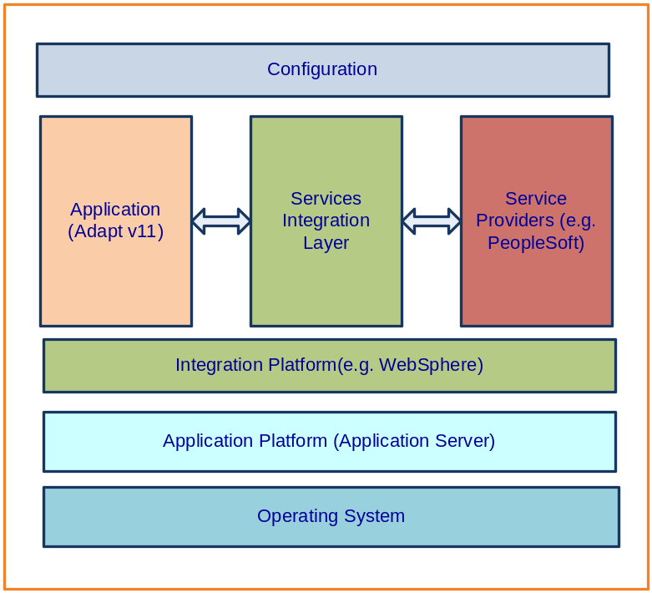
Figure 2 - Application Architecture Reference Model

The key principles enforced by the reference model are:

- Sub-systems within the Application architecture will be loosely coupled
- Integration between systems will be implemented through an integration layer as opposed to direct integration
- Integration will be achieved through the use of well defined interfaces.
- Service Integration layer will make use of configuration to select the service provider. This will allow localisation of service providers without affecting the core Adapt product

Logical View

The figure below presents a logical view of the Adapt v11 Global system and the localisation approach.

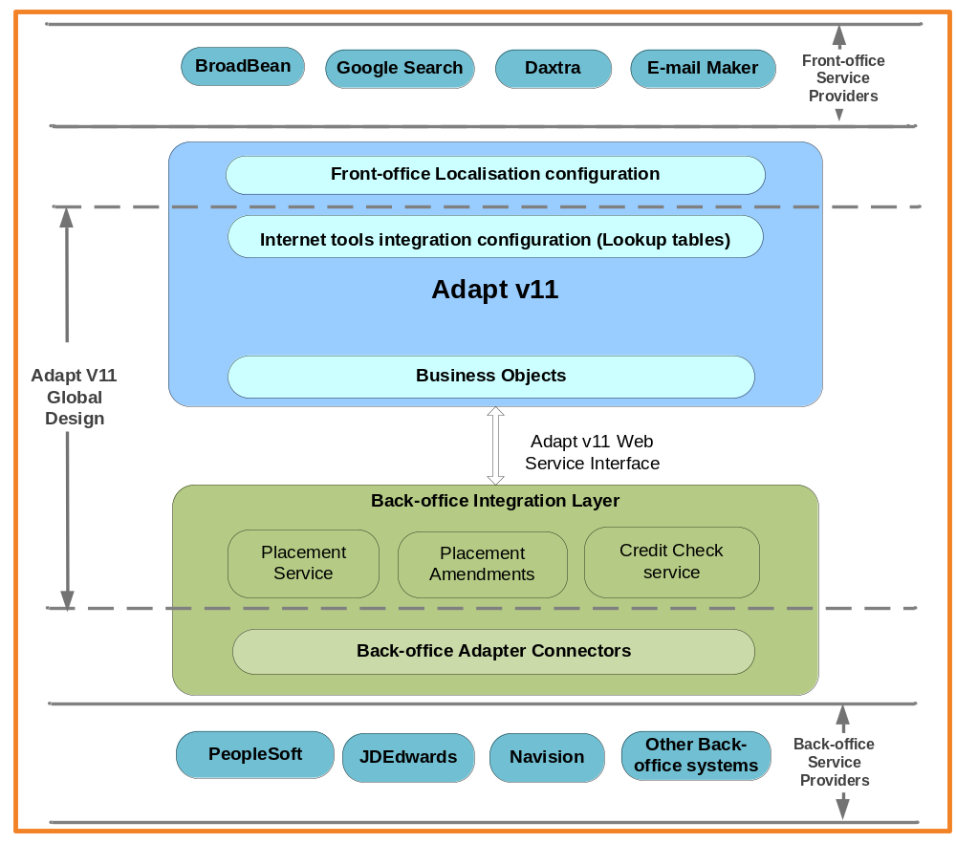

Application Components and Integrations
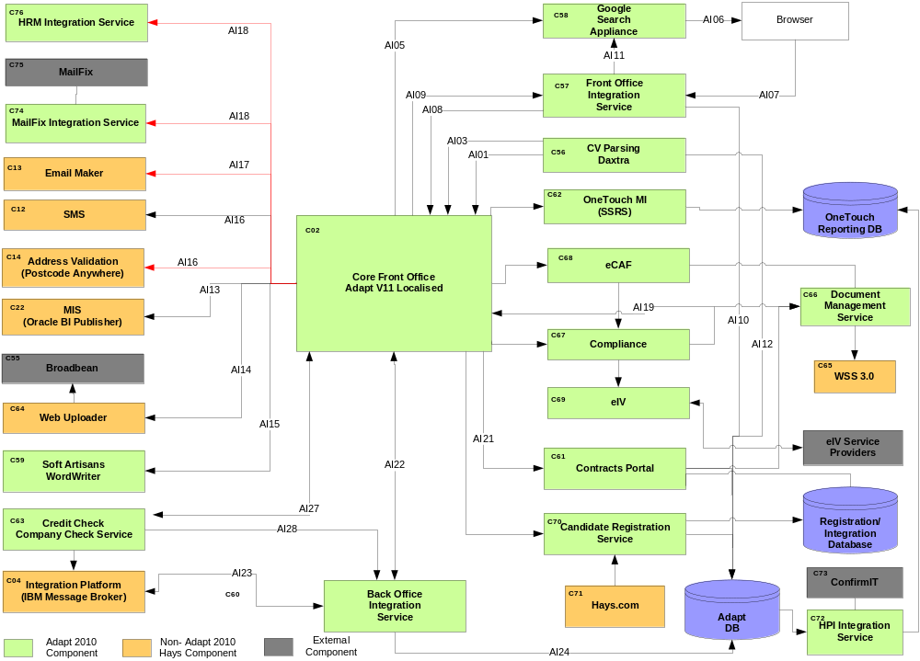

Component List

Hays Hosted Components
The following components will be managed and hosted internally by Hays. The status column defines the following values:
- New A new application to Hays
- Upgrade A new version of an application that currently exists in Hays and is in scope of the Proveho programme
- Existing The same version of an application that currently exists in Hays

ID | Component | Functional Summary | Provider | Product/Version | Status | Notes
C02 | Adapt | Provides the front end functionality for managing candidate, job and client data and for matching this data to form a placement for sending through to the Back Office. | Bond | Adapt V11 (Localised)  OS: TBD  Database: Oracle | Upgrade | This is an upgrade of the existing Adapt v8 application. This does not include other variations of Adapt v8 which are covered elsewhere.
C04 | Integration Platform | This provides the validation, translation and orchestration logic required to integrate the front office application, processes and data with the back office application, processes and data. It also acts as the central point for managing any external web services required. | IBM | Websphere Message Broker  OS: Unix  Database: Oracle | New | It should be noted this is not intended to manage the file transfers required as part of the Proveho solution. This will be delivered by the Enterprise File Gateway (C21)
C12 | Email Maker | This is a shared email function across the solution, which will receive messages from Core Front Office, Core Back Office and Document Management to send out as emails. | Hay Web Team | Exchange 2003  OS: Windows | Existing | There may be a requirement to send emails from the Integration platform for service management processes however this is omitted for now, as no explicit requirement exists.
C14 | Address Validation | This provides validation functionality around addresses and postcodes. The component will take basic address information and return detailed address information while also validating any detail provided via self-service functions. | Postcode Anywhere | UK Address Data | New | This is implemented locally as a database within Hays and hence will be called directly by PeopleSoft and Adapt.  PeopleSoft and Adapt based on a full selection process selected this product as the best solution for use.
C22 | Financial | This provides the functionality to select the required data from operational systems and create defined management reports. | SAP | Business Objects | Upgrade | Assumption that this will provide MIS information which is not available from native PeopleSoft or Adapt, or requires reporting logic or data not available in either application.  Any extraction, transform and load activities required for this are deemed out of the scope of OneTouch.  Business Objects is the working assumption but this may change as a result of the MI workstream findings.
C56 | DaXtra | This provides a CV parsing and processing service to Adapt. This component reads incoming CV posted by candidates in response to a job advertisement from an email server (Exchange Server) and create/update candidate information in Adapt system. | daXtra | JBoss 4.2.3.GA  OS: RedHat Enterprise Linux  Database : MySQL | New | daXtra provides an integrated hardware and software that will be hosted within Hays infrastructure. This platform will be managed by daXtra remotely to provide support and maintenance of this system over a VPN connection
C57 | Front Office Integration Service | This is an external component to Adapt which will be used to manage all front office interfaces integration  Google  Company Hierarchy  Data Enrichment  These services will then be offered as part the global model as part of future rollouts. | Hays Adapt 2010 team | JBoss 4.2.3.GA  OS: Windows  Database : Oracle  .Net 3.5/IIS 6.0  OS: Windows  Database : Oracle | New | This service will be deployed onto a separate JBoss application server and communicate with Adapt and other front office interface using a variety of protocols (e.g. HTTP, SOAP, JMS, JDBC ,etc …). These interfaces are GSA, Data Enrichment server side invocation and Company hierarchy.  Data Enrichment application will be hosted under Hays .Net server farm.
C58 | Google Search Appliance | The Google Search Appliance crawls Adapt database for candidate information as well as CV and creates a master index of documents that's ready for instant retrieval using Google's search technology, whenever a consultant types in a search query to long list candidates using the Google link provided in Adapt. | Google |  | New | Google provides an integrated hardware and software that will be hosted within Hays infrastructure. This platform will be managed by Google remotely to provide support and maintenance of this system over a VPN connection
C60 | Back Office Integration Service | This is an external component to Adapt which will be used to manage the inbound and outbound queues required for back office and validation service integration. These services will then be offered as part the global model as part of future rollouts. | Hays Adapt 2010 | JBoss 4.2.3.GA  OS: TBD  Database : Oracle | New | This service will be deployed onto a separate JBoss application server and communicate with Adapt and integration platform using Web Service and JMS protocols
C61 | Contracts Portal | Provides compliance, contract and pricing matrix to all front-office related activities | Hays Adapt 2010 team | Net 3.5 application  IIS 6.0  OS: Windows 2003  Database : SQL Server 2005 | New | This portal will be hosted in Hays .Net server farm.
C62 | Operational Reporting (SSRS) | To provide Adapt operational reporting features built using SQL Server Reporting Services | Hays Adapt 2010 team | SQL Server Reporting Services  OS: Windows 2003  IIS 6.0  Database: SQL Server 2008  Oracle 10g | New | This platform will use Adapt Disaster Recovery (DR) Oracle infrastructure to report against using SQL Server Reporting Services platform. It is envisaged to report against 1 day older Adapt data copied over to DR.
C63 | Credit Check/Company Check Service | Company Check service will be used to validate company details entered in Adapt as part of job registration workflow. The consultant supplied company details will be validated by an external provider service (Equifax) triggered by Integration Platform  Credit Check service will be used to verify the credit details of a company as part of job registration process | Hays | JBoss 4.2.3.GA  OS: Windows 2003 | New | The company and credit check interfaces will be exposed within integration platform for Adapt to access it.  Adapt host this service in Hays JBoss farm (possibly other than Back-Ofiice integration service JBoss instance) interfacing to IP exposed services.
C64 | Web Uploader | This component is responsible interfacing with BroadBean, an external component sourced by Hays for Job advertisement/post | Hays | .Net 3.5 application  IIS 6.0  OS: Windows 2003  Database : SQL Server 2005 | New | This component will be deployed to Hays .Net server farm which will interface with Adapt and Job advertisement platforms (e.g Broadbean)
C65 | Document Management  (WSS 3.0) | To store all compliance, client contract related documents acquired in Adapt V11 and V8 systems. | Microsoft | Windows SharePoint Services 3.0  OS: Windows 2003  Database: SQL Server 2005 | New | Documents currently flagged to be managed via this are:  - Compliance documents  - Photocopied or faxed passport photographs  - Client contract management  - Terms of Business  - Terms of Assignment  Note: This is expected to be a phased implementation hence all documents may not be included on day 1.
C66 | Document Management Service | This service will be provides document capture, document view including meta-data of captured documents | Hays | .Net Web Application  IIS 6.0  OS: Windows 2003  Database : SQL Server 2005 | New | This service will be provisioned under the server where Windows SharePoint Service is hosted.
C74 | Mailfix Integration Service | The service provides integration with the Mailfix Portal. | Hays
C76 | HRM Integration Service | This service provides integration with HRM Workflow systems, which are currently Adapt v8 based. | Hays

3rd Party Components
The following components will be managed and hosted external to Hays but are included to complete the end to end process:

ID | Component | Functional Summary | Provider | Product/Version | Status | Notes
C55 | BroadBean | Broadbean is a third party tool used to broadcast the jobs to job boards. Adapt V11 will use Broadbean to advert, status enquiry and delete the job from job sites. Job details will be prepared as XML file and HTTP post to Broadbean. | BroadBean | BroadBean | New | This is a public internet website hosted by a third party to provide job advertisement service to staffing industry. All we need to have an access to this website from Adapt with a configured list of username/password
C72 | ConfirmIT | ConfirmIT services are currently being used to monitor HAYS performance based on feedback from clients, contacts and candidates | ConfirmIT | ConfirmIT | New

Component Interaction Points
Adapt and various component interaction points have been depicted in below table:-

ID | Source | Target | Description | Format | Transport | Type | Trigger | Frequency | Complexity | Status
AI01 | Daxtra | Adapt | Daxtra loads CVs on to Adapt | XML | SOAP | Real Time | Candidate loads CV onto Daxtra | As Required | N/A | Existing
AI02 | Daxtra | Adapt | Daxtra reads candidate information from the Adapt database | SQL | JDBC | Real Time | Candidate changes their data | As Required | N/A | Existing
AI03 | Daxtra | Adapt | Daxtra creates/updates candidate information | XML | SOAP | Real Time | Candidate changes their data | As Required | N/A | Existing
AI04 | Adapt | Post Code Anywhere(PCA) | Adapt sends post code data to PCA | XML | SOAP | Real Time | Consultant requires post code address validation | As Required | N/A | Existing
AI05 | Adapt | GSA | Adapt invokes search page on GSA | HTML | HTTP | Real Time | Consultant selecting candidates for short list | As Required | Low | New
AI06 | GSA | Browser | Browser screen launched with custom Google search. | HTML | HTTP | Real Time | As Above | As Required | Medium | New
AI07 | Browser | SIS | Short list passed to the Search Integration Service. | XML | HTTP | Real Time | As Above | As Required | Medium | New
AI08 | SIS | Adapt | Create a shortlist of candidates | XML | SOAP | Real Time | As Above | As Required | Medium | New
AI09 | Adapt | SIS | Candidate information updates, passes an ID | XML | HTTP | Real Time | Consultant updates a Candidates info | As Required | High | New
AI10 | SIS | Adapt DB | Get the candidate details using the ID passed in AI09 | SQL | JDBC | Real Time | As Above | As Required | High | New
AI11 | SIS | GSA | Passes the changed candidate details to The Google Search Appliance | XML | HTTP | Real Time | As Above | As Required | Medium | New
AI12 | GSA | Adapt DB | Read data to update the GSA indexes | SQL | JDBC | Batch | Scheduled | Hourly | Medium | New
AI13 | Adapt | Integration  Platform | See Proveho Integration Architecture

AI14 | Adapt | Web Uploader | Loads Jobs on to Broadbean | XML | HTTP | Real Time | Consultant creates a job | As Required | N/A | New
AI15 | Adapt | Word Writer | Created Documents  and mail merge | File | FTP | Real Time | Out of the box function | As Required | N/A | Existing
AI16 | Adapt | SMS | Text messages | e-mail | SMTP | Real Time | Notification | As Required | N/A | Existing
AI17 | Adapt | Email | E-Mail | e-mail | SMTP | Real Time | Requirements not yet defined | As Required | ? | ?
AI18 | Adapt | Mail | Print House | File | FTP | Batch | Requirements not yet defined | Daily | ? | ?
AI19 | Adapt | DMS | Adapt link to document management system to see/capture candidate, compliance documents. | HTML | HTTP | Real Time | The documents captured by Adapt gets stored under WSS 3.0 | As Required | N/A | New
AI20 | Adapt | MIS (Business Objects) | Adapt link to MIS to view reports | HTML | HTTP | Real Time | Requirements not yet defined | As Required | N/A | New
AI21 | Adapt | Contracts Portal | Adapt link to Contracts Portal to see agreement linking to job/placement, pricing matrix and compliance | HTML | HTTP | Real Time | Requirements not yet defined | As Required | N/A | New
AI22 | Contracts Portal | Adapt | Pricing matrix data gets stored back in Adapt | XML | SOAP | Real Time | Requirements not yet defined | As Required | N/A | New

AI23 | Adapt | Back-Office Integration Service(BOIS) | Consultant confirms a placement or update any shared data | HTML | HTTP | Real Time | Consultant confirms a placement record or update shared data for back-office system to process | As Required | N/A | New
AI24 | Integration Platform | BOIS | BOIS updates adapt with back-office response details | XML | SOAP | Real Time | When integration platform updates inbound queue with back-office response | As Required | N/A | New
AI25 | BOIS | AdaptDB | BOIS update Adapt staging database table | XML | JDBC | RealTime | When Outbound/Inbound queues are populated by messages | As Required | N/A | New
AI26 | BOIS | Contract Portal | Retrieve agreement details associated in a placement or job | XML | SOAP | RealTime | When BOIS prepares Placement messages | As Required | N/A | New
AI27 | Adapt | Company/Credit Check Service | To validate company details | XML | SOAP | RealTime | When consultant registers a new job | As Required | N/A | New
AI28 | Company/Credit Check Service | BOIS | To validate company credit details | XML | JMS | RealTime | When consultant completes a job registration | As Required | N/A | New

Integration Mechanism
Web Services will be the preferred mechanism for integrating with Adapt except back office integration which uses messaging. External application will gain access to Adapt data objects and entities only through Web Service calls. As a general principle, direct access to Adapt v11 database by external applications will be prohibited unless there is a specific case for it. Adapt v11 exposes the following web services:
- Search Service
- Entity Access Service
- Code Group Access Service
- Document Access Service
- Journal Access Service
- Tasks Access Service
- Calendar Access Service
- Business Object Executor Service

The Adapt 2010 Detailed Design document will provide details of how these services will be used.

Address Lookup Integration (C14)
Address lookup integration is vital in order to validate address details of various entities (e.g. contact, client, etc…) created in Adapt. Adapt system provides out of the box integration with Post Code Anywhere (PCA), a widely used address lookup system in the UK and around the world. Hays will host PCA system in the designated data centre for both front office and back office systems. The post code data will get updated periodically (probably monthly) in the data centre environment by PCA. The Adapt system will be configured to use Hays hosted PCA web service URL in order to validate address details.

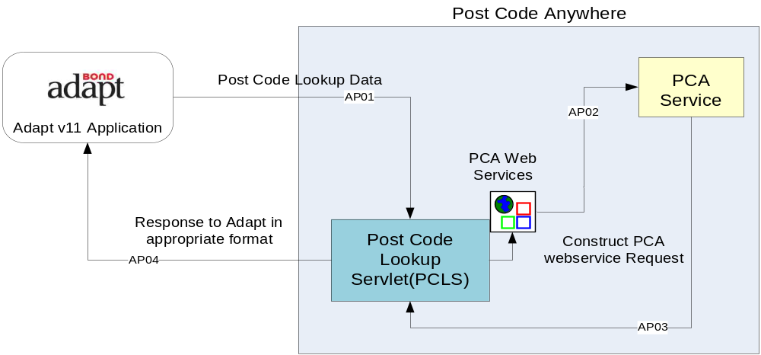
Adapt consultant places a request for post code lookup with appropriate data (post code snippet, address line, house/flat number etc…) to Adapt postcode Lookup Servlet. The servlet pre-processes the input parameters, send a PCA webservice request that will get processed by PCA and send response back to servlet. The servlet pre-processes PCA response and send data back to Adapt user interface either a set of address result set or an exception.
The Address Lookup architecture interaction points summarised in below table:
ID | Source | Target | Description | Format | Transport | Type | Trigger | Frequency
AP01 | Adapt | PCLS | Adapt sends Post code lookup parameters | XML | HTTP | Real Time | When Consultant requests for post code validation | As Required
AP02 | PCLS | PCA WebService | Construct PCA web service request and sends out to PCA | XML | SOAP | Real Time | When PCLS receives post code lookup parameters | As Required
AP03 | PCA web service | PCLS | Response from PCA to PCLS | XML | SOAP | Real Time | When PCA completes post code lookup service | As Required
AP04 | PCLS | Adapt | PCLS sends out PCA response to Adapt in its xml format | XML | HTTP | Real Time | When PCLS receives PCA response message | As Required

CV Parsing Service Integration (C56)
Hays is using Daxtra’s CV parsing technology that analyses free text CVs and accurately processes their content into a set of structured fields. These are then used to automatically create or update records on the Adapt database. Contact details, skills, industries, job titles, education and job histories are just some of the examples of fields that are automatically processed.

The candidates who submit his/her CV against a job advertisement will get sent to a designated Hays mailbox (setup based on the job specialism) along with the Adapt JOB reference as the email subject. Daxtra servers poll each of these mailboxes periodically and create/update candidates against each of the job references using a combination of Adapt web service call and database updates. Any exception occurred during this process will be captured within the exception queue within Daxtra and manually corrected by the service centre team.

Daxtra servers will be hosted within Hays data centre and managed by Daxtra using a web interface accessible over a secured VPN. Daxtra software is hosted within Red Hat Enterprise Linux servers and using MySQL as the backend database servers.

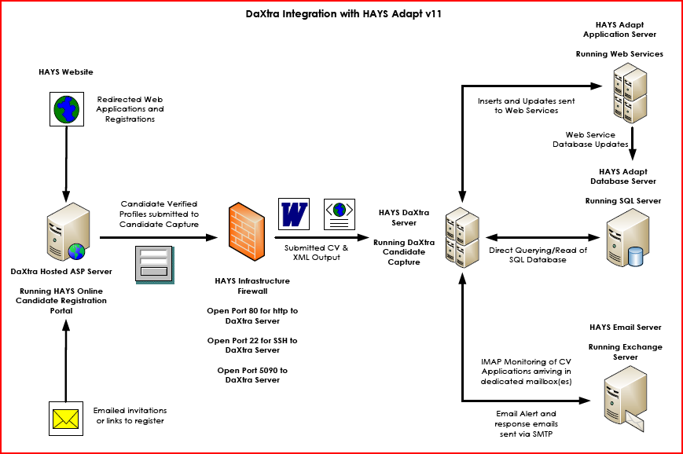
Figure 3 - DaXtra CV Processing Integration

Back Office Integration Component (C60)
The back office integration component (BOIS) provisions a set of services that integrate with core back office systems. The UK version of BOIS supports the following services at the moment and there is a desire to extend the existing services to work with CERoW and APAC back office systems by adding more service adapters.
- JDE Integration Service – This service integrates with the existing JDE back office systems through WebMethods integration platform
- PeopleSoft Integration Service – This service integrates with the to be back office system PeopleSoft through IBM message broker
- Company Check Service – This service enables OneTouch systems to validate worker or client company details through IBM message broker over web service using Equifax as the service provider. The details of this integration can be obtained from - http://hsrdk2k7sp1/haysit/pmo/adapt/InterfaceDesignBuild/03%20Design/Credit_CompanyCheck_Detailed_Design_1.0.doc
- Credit Check Service - This service enables OneTouch systems to credit check worker or client company details through IBM message broker over message queues using Equifax as the service provider. The details of this integration can be obtained from http://hsrdk2k7sp1/haysit/pmo/adapt/InterfaceDesignBuild/03%20Design/Credit_CompanyCheck_Detailed_Design_1.0.doc
- eProfile Integration Service – This service enables PeopleSoft portal to integrate with Adapt whenever worker updated their details. This integration is through IBM message broker over message queues.

Global Back Office Integration

The global back office integration design is taken into the consideration of using a messaging driven architecture to store all Outbound and Inbound messages flowing between front and back office systems. The outbound queue will store all placements and update messages coming from Adapt for back office integration layer. The messages get populated in Outbound Queue by Back Office Integration Services (B OIS) specifically Outbound Queue Polling Service (OQPS) deployed in Adapt application server. These messages get processed by Back Office Stub service and create a database record in Adapt DB staging table. The whole purpose of this exercise is to support development and testing of Back office integration while localised back office integration layer has been developed. The localization requirements will replace this stub with an integration platform (e.g. WebSphere Message Broker) or re-use BOSIS to send message to back office systems.
When localised back office layer is available this mechanism will be turned off using configuration parameters defined in the BOIS artefact. The message response sent by the Back Office Stub Service will be posted in an Inbound Queue for Inbound Queue Polling Service (IQPS) to process. The messages in Adapt Inbound Queue will get processed by IQPS and updates Adapt using BO Web Services.

The global back office architecture summarised below:

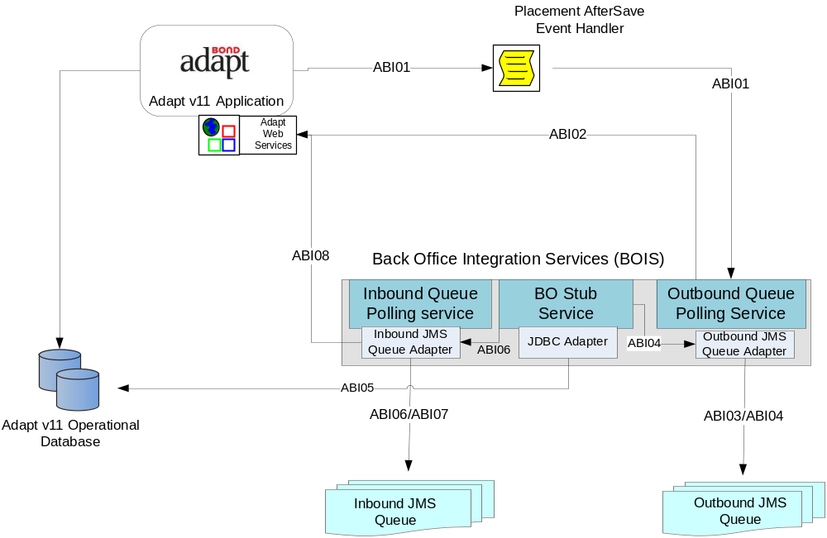Figure 4 – Global Back Office Integration

The architecture interaction points summarised in below table:

ID | Source | Target | Description | Format | Transport | Type | Trigger | Frequency
ABI01 | Adapt | BOIS( Outbound Queue Polling Service) | Adapt creates placement record.  Adapt update any shared data such as client, worker, contact, and Assignment | XML | HTTP | Real Time | Consultant creates placement or updates shared data | As Required
ABI02 | BOIS( Outbound Queue Polling Service) | Adapt | BOIS( Outbound Queue Polling Service) retrieves records from DB and construct create placement or update request messages | XML | SOAP | Real Time | BOIS( Outbound Queue Polling Service) receives data from Adapt | As Required
ABI03 | BOIS( Outbound Queue Polling Service) | Outbound Queue | BOIS (Outbound Queue Polling Service) creates placement or update shared data message request to Outbound Queue | XML | JMS | Real Time | When BOIS receives placement or shared data changes notification | As Required
ABI04 | BOIS ( BO Stub Service) | Outbound Queue | BOIS (BO Stub Service) poll Outbound Queue for placement and shared data sends by Adapt | XML | JMS | Real Time | When Outbound Queue receives create placement or shared data message requests | As Required
ABI05 | BOIS ( BO Stub Service) | Adapt DB | BOIS ( BO Stub Service) creates database record in Adapt for stub purpose while integration layer has been developed | XML | JDBC | Real Time | When Outbound Queue receives create placement or shared data message requests | As Required
ABI06 | BOIS ( BO Stub Service) | Inbound Queue | BOIS ( BO Stub Service) sends response message to Inbound Queue for stub purpose while integration layer has been developed | XML | JMS | Real Time | When BOIS receives response stub BO Service | As Required

ABI07 | BOIS ( BO Stub Service) | Inbound Queue | BOIS ( BO Stub Service) poll messages from Inbound Queue | XML | JMS | Real Time | When BOIS receives response stub BO Service | As Required
ABI08 | BOIS ( Inbound Queue Polling Service) | Adapt | QPS reads Inbound Queue and update Adapt | XML | SOAP | Real Time | When Inbound Queue receives update message from Integration Platform | As Required

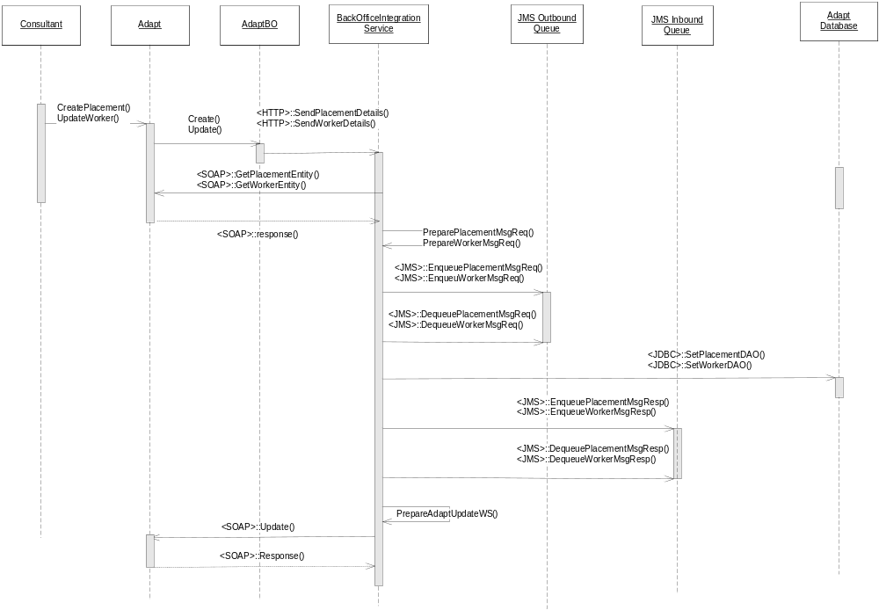

JD Edwards to PeopleSoft transition (UK only)
From a backend integration perspective, the major issue is around the UK backend since it involves a transition from JD Edwards to PeopleSoft. This involves not only a technology change, but also a significant business change. One of the key drivers for the transition is to remove/reduce the manual processing that is currently required in the backend. The agreed solution is to use the integration platform in phase 1 of the transition. This is summarised below:

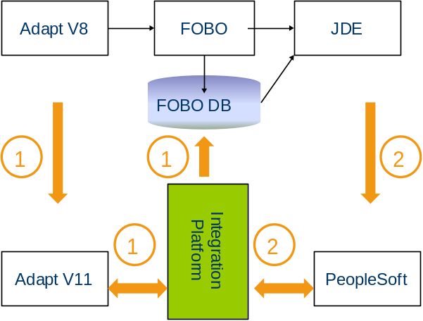

- The Business processes need to be configured only once, targeting PeopleSoft
- Business change happens only once
- JDE and PeopleSoft can be run in parallel which mitigates business risk
- No need to develop a throwaway FOBO2
- Phased approach to testing since the transition around front end business processes gets tested in phase 1 which helps in focussing phase 2 on the backend transition
- Some work would be required to make JDE work with the “to-be” processes
- First drop of Adapt v11 will have a dependency on availability of Integration platform

The interim JDE integration solution will be designed using Hays existing integration platform (WebMethods) and this will get replaced as soon as Proveho integration platform is made available. The interim solution will make use of the global back office integration reference architecture and matching with the Proveho back office integration vision. The placement messages are stored in a queue as described below and in the Proveho solution architecture document. The message format of placement data should be in the agreed format expected by PeopleSoft so that the integration work can be minimised when Proveho integration platform is available.

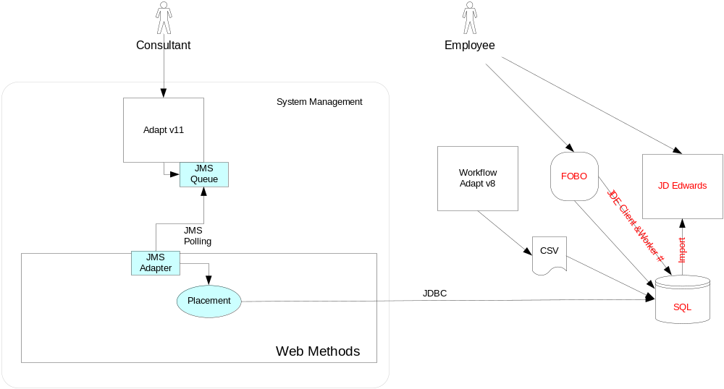

The current Hays WebMethods integration platform does not licence to use a JMS adapter which will have an impact to our global back office integration reference model. In order to meet the Global Back office integration reference architecture model where possible, Adapt created placement and other update request messages get polled from outbound queue by a stub service to Adapt staging database table. WebMethods poll this database table for placement messages, route this message to FOBO database over JDBC after applying necessary transformation logic to create FOBO expected database record. The response (e.g. success or failure status) received from Web Methods will be stored in Adapt DB, this response message will be polled by the Back Office Stub Service and inject into the Inbound Queue for Polling Service to process (this would be the only exception from the global back office integration reference model). The database record created in FOBO for placement by the integration platform will follow the current FOBO mechanism to process the record in JDE expected format.

The integration details can be obtained from http://hsrdk2k7sp1/haysit/pmo/adapt/InterfaceDesignBuild/03%20Design/Adapt%20v11%20Back-Office%20Integration%20Technical%20Design%20(WebMethods-JDE)%20V1.0.doc
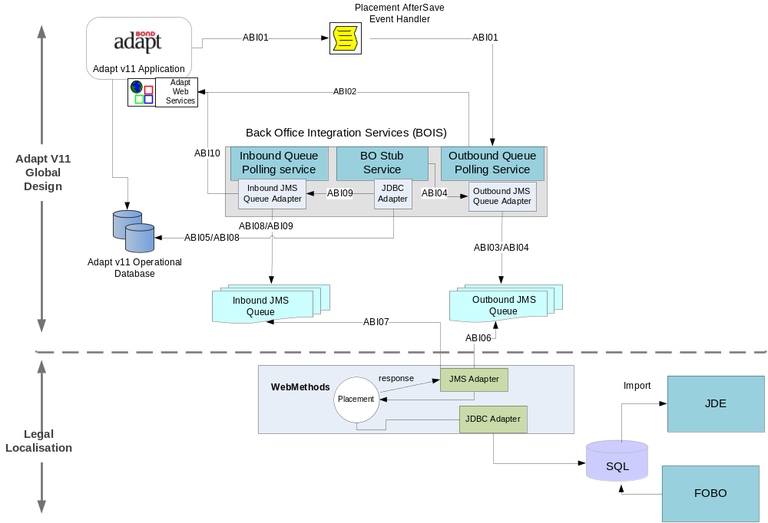
Figure 5 – JDE Integration
ID | Source | Target | Description | Format | Transport | Type | Trigger | Frequency
ABI01 | Adapt | BOIS( Outbound Queue Polling Service) | Adapt creates placement record.  Adapt update any shared data such as client, worker, contact, and Assignment | XML | HTTP | Real Time | Consultant creates placement or updates shared data | As Required
ABI02 | BOIS( Outbound Queue Polling Service) | Adapt | BOIS( Outbound Queue Polling Service) retrieves records from DB and construct create placement or update request messages | XML | SOAP | Real Time | BOIS( Outbound Queue Polling Service) receives data from Adapt | As Required
ABI03 | BOIS( Outbound Queue Polling Service) | Outbound Queue | BOIS (Outbound Queue Polling Service) creates placement or update shared data message request to Outbound Queue | XML | JMS | Real Time | When BOIS receives placement or shared data changes notification | As Required
ABI04 | BOIS ( BO Stub Service) | Outbound Queue | BOIS (BO Stub Service) poll Outbound Queue for placement and shared data sends by Adapt | XML | JMS | Real Time | When Outbound Queue receives create placement or shared data message requests | As Required
ABI05 | BOIS ( BO Stub Service) | Adapt DB | BOIS ( BO Stub Service) creates database record in Adapt for stub purpose while integration layer has been developed | XML | JDBC | Real Time | When Outbound Queue receives create placement or shared data message requests | As Required
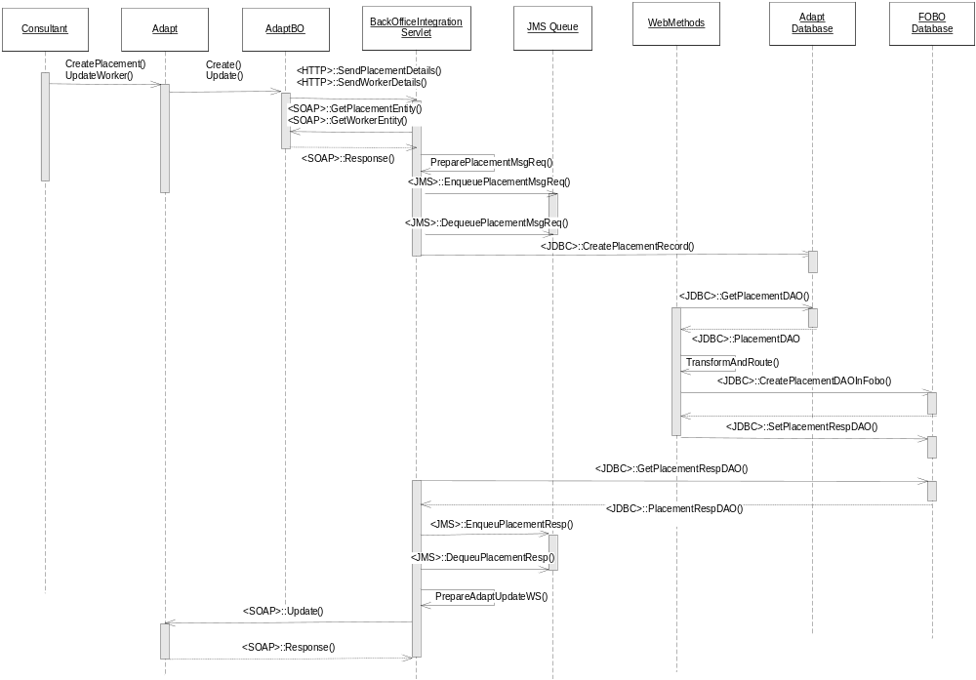
ID | Source | Target | Description | Format | Transport | Type | Trigger | Frequency
ABI06 | WebMethods | Adapt DB | Web Methods reads Adapt designated table for new placement records | XML | JDBC | Real Time | When Adapt DB receives data from BO Stub Service | As Required
ABI07 | Web Methods | Adapt DB | Web Methods updates Adapt designated table row with response message and status | XML | JDBC | Real Time | When web methods updates Adapt DB table | As Required
ABI08 | BOIS ( BO Stub Service ) | AdaptDB | BOIS ( BO Stub Service ) reads Adapt DB for response message | XML | JDBC | Real Time | When web methods updates Adapt DB table | As Required
ABI09 | BOIS ( BO Stub Service ) | Inbound Queue | BOIS ( BO Stub Service ) send Adapt DB for response message to Inbound Queue using Queue Polling Service | XML | JDBC | Real Time | When web methods updates Adapt DB table | As Required
ABI10 | BOIS ( Inbound Queue Polling Service) | Adapt | Queue Polling Service reads Inbound Queue and update Adapt using web services | SOAP | Real Time | Real Time | When Inbound Queue receives update message from Integration Platform | As Required

PeopleSoft Interface
The PeopleSoft interface will be provided through the integration platform which is being built as part of the Proveho programme. From an Adapt v11 architecture perspective, the key requirements are to:
- Define the mechanism for communicating with the Proveho integration platform
- Define the interfaces that need to be exposed by Adapt v11

Messaging is the preferred communication mechanism since it is the industry standard.

The integration details can be obtained from http://hsrdk2k7sp1/haysit/pmo/adapt/InterfaceDesignBuild/03%20Design/Adapt%20v11%20Back-Office%20Integration%20Technical%20Design%20(WebSphere-PS)%20V1.0.doc

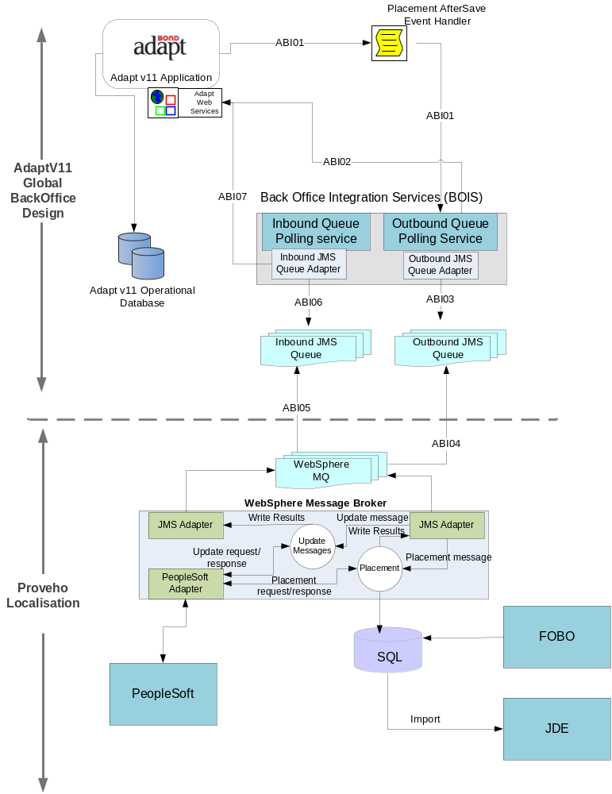

Figure 6 – PeopleSoft Integration
ID | Source | Target | Description | Format | Transport | Type | Trigger | Frequency
ABI01 | Adapt | BOIS( Outbound Queue Polling Service) | Adapt creates placement record.  Adapt update any shared data such as client, worker, contact, and Assignment | XML | HTTP | Real Time | Consultant creates placement or updates shared data | As Required
ABI02 | BOIS( Outbound Queue Polling Service) | Adapt | BOIS( Outbound Queue Polling Service) retrieves records from DB and construct create placement or update request messages | XML | SOAP | Real Time | BOIS( Outbound Queue Polling Service) receives data from Adapt | As Required
ABI03 | BOIS( Outbound Queue Polling Service) | Outbound Queue | BOIS (Outbound Queue Polling Service) creates placement or update shared data message request to Outbound Queue | XML | JMS | Real Time | When BOIS receives placement or shared data changes notification | As Required
ABI04 | Outbound Queue | WebSphere MQ | Transfer local JMS Outbound Queue messages to WebSphere MQ | XML | JMS | Real Time | When Outbound Queue receives create placement or shared data message requests | As Required
ABI05 | WebSphere MQ | Inbound Queue | Transfer back office response messages from WebSphere MQ to Inbound queue | XML | JMS | Real Time | When back office sends response back to integration platform | As Required

ABI06 | BOIS( Inbound Queue Polling Service) | Inbound Queue | BOIS( Inbound Queue Polling Service) reads Inbound Queue | XML | JMS | Real Time | When Inbound Queue receives response messages from WebSphere MQ | As Required
ABI07 | BOIS ( Inbound Queue Polling Service) | Adapt | Queue Polling Service reads Inbound Queue and update Adapt using web services | SOAP | Real Time | Real Time | When Inbound Queue receives update message from Integration Platform | As Required

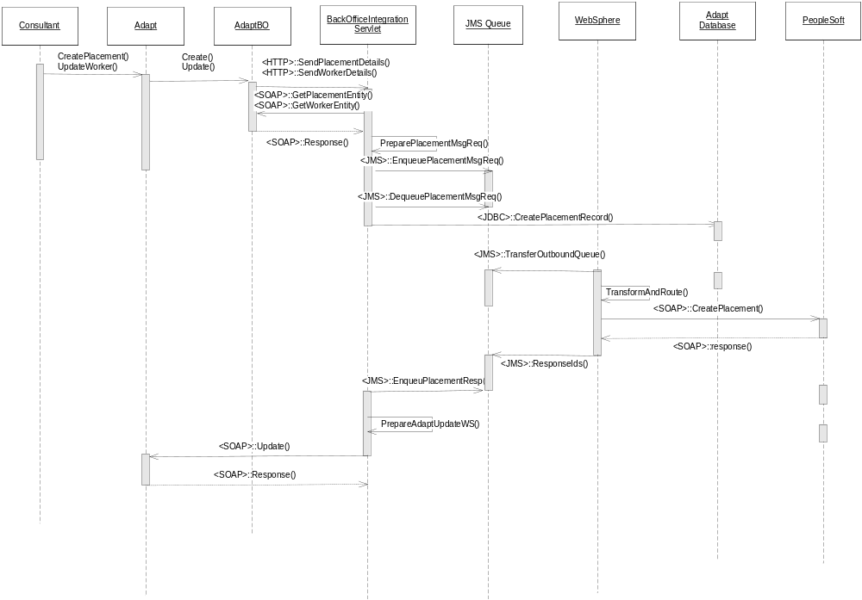

Search – Google Search Appliance (C58)
Hays leverages on Google Search Appliance and Google Maps API (GeoCoding service) for search and maps integration with Bond Adapt recruitment platform. The GSA server collections will be populated with candidate, contact and job entity feed details (metadata and CVs for full text search) as and when these records get created/ updated in Adapt system by either consultants or CV parsing software Daxtra (e.g. Candidates). GSA will be configured to create different collections per various Hays country/region, e.g. UK will have separate collections for each of the feed entities.

GSA has been configured for creating custom search front ends (the well known Google search UI) for Contact, Candidate and Job entities in order to support meta data and full text search for consultants efficiently.

In order to support Hays disaster recovery standards, a separate GSA server will be purchased and populated as soon as primary GSA server has been populated with data feed with any of the agreed Adapt entities.

Google Maps API, Geocoding service will be used to load map details at run-time using their post code information. The map details retrieved using Google Geocoding service is similar to the one you see in maps.google.com.

The high level architecture model is presented below.

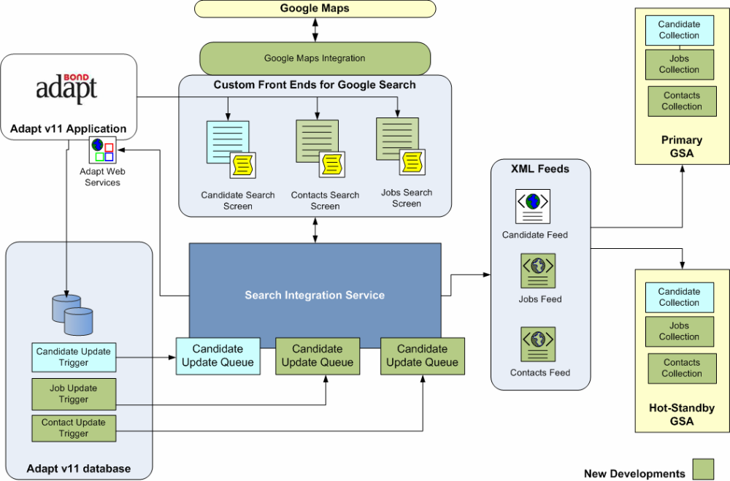

Front Office Integration Service (C57)
The front office integration service component is responsible for exposing the necessary interfaces/touch points to integrate with third party software component interfaces, providers or other components within Hays enterprise.

This component comprises of a collection of callable interfaces described below:

- GSA Search Integration Service
- Data Enrichment Service
- Organisation Hierarchy Service
- Maps Integration Service

The details of each of these sub-components are depicted in below sections.

Google search Integration (Candidate Search)
Candidate search in Adapt will launch a separate browser window to display all candidate search results using Google custom front end URL. Adapt will pass all the necessary input parameters (e.g. job_id) and search parameters to Google custom front end URL. Google custom front end URL will be configured in a lookup entity table in Adapt for easy maintenance. The interaction detail of Google candidate search integration is depicted below.

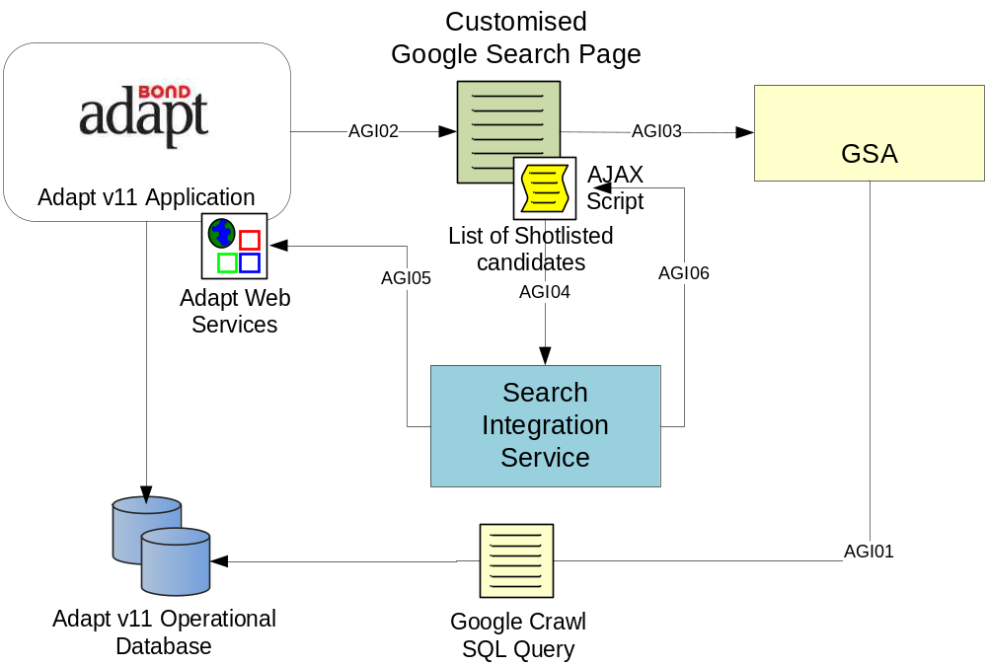

Figure 7 – Candidate Search Integration
ID | Source | Target | Description | Format | Transport | Type | Trigger | Frequency
AGI01 | GSA | Adapt DB | GSA executes crawl query to build index | XML | JDBC | Scheduled | When Adapt receives candidate records either consultant or daXtra | As Required
AGI02 | Adapt | Custom Google Page | Consultant launches Google candidate search link from Adapt | XML | HTTP | Real Time | When consultant requires to shortlist or long list candidates | As Required
AGI03 | Custom Google Page | GSA | Consultant refines search | XML | HTTP | Real Time | When consultant refines search criteria | As Required
AGI04 | Custom Google Page | SIS | Consultant short lists candidates from custom Google search page and send list of short listed candidates to Search Integration Service | XML | HTTP | Real Time | When consultant refines search criteria and short list candidates | As Required
AGI05 | SIS | Adapt | Search Integration Service invokes Adapt web service interface to update/insert long list or shortlist candidates. | XML | SOAP | Real Time | When consultant refines search criteria and short list candidates | As Required
AGI06 | SIS | Custom Google Search Page | Search integration service sends success or failure response back to Google custom search page | XML | HTTP | Real Time | When consultant refines search criteria and short list candidates | As Required

Google search Integration (Candidate Update – XML feeds to GSA)
This mechanism sends candidate update details to Google search appliance whenever candidate details get updated either by consultant or daXtra interface. The interaction detail of Google candidate update integration is depicted below.

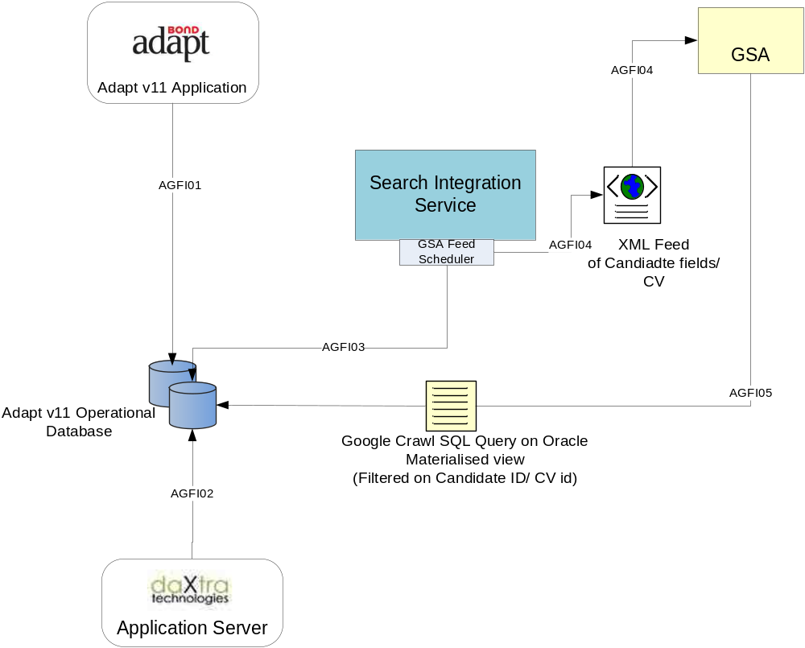

Figure 8 – Candidate Update (GSA Feed) Integration
ID | Source | Target | Description | Format | Transport | Type | Trigger | Frequency
AGFI01 | Adapt | Adapt DB | Consultant updates Candidate record in Adapt | XML | JDBC | Real Time | When Consultant updates candidate records | As Required
AGFI02 | daXtra | Adapt DB | daXtra CV processing component updates candidate record in Adapt | XML | JDBC | Real Time | When daXtra CV processing component updates candidate records | As Required
AGFI03 | GSA Feed Scheduler | Adapt DB | Search Integration service, GSA Feed Scheduler component polls an Oracle table for all updated candidate records and cvs populated using triggers and stored proc whenever consultant or daXtra updates candidate records. | XML | JDBC | Scheduled | When GSA scheduler service reaches its next iteration | As Required
AFFI04 | GSA Feed Scheduler | GSA | GSA Feed Scheduler creates GSA feed xml and performs HTTP posy | XML | HTTP | Real Time | When GSA scheduler service retrieves data from Adapt DB | As Required
AGFI05 | GSA | Index | GSA rebuild index | XML | HTTP | Real Time | When GSA receives XML feed | As Required

Data Enrichment Service
This service is used to process daXtra obtained candidate CV additional details information using a web front end, so that the consultants can group it logically and store it under Adapt DB. The detailed design can be obtained from http://hsrdk2k7sp1/haysit/pmo/adapt/InterfaceDesignBuild/Workstream%20Specific/Data%20Enrichment/Adapt%20V11%20Interfaces%20Data%20Enrichment%20Design%20V0.1.doc

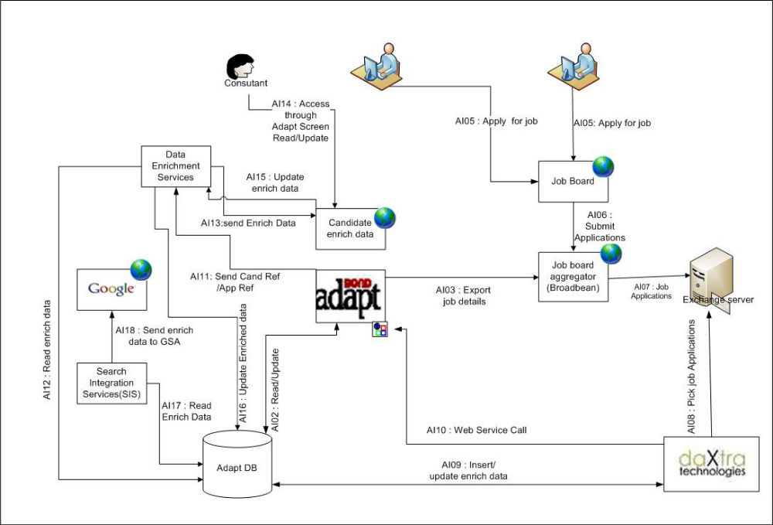

Google Maps Integration Service
Details of this integration can be obtained from -

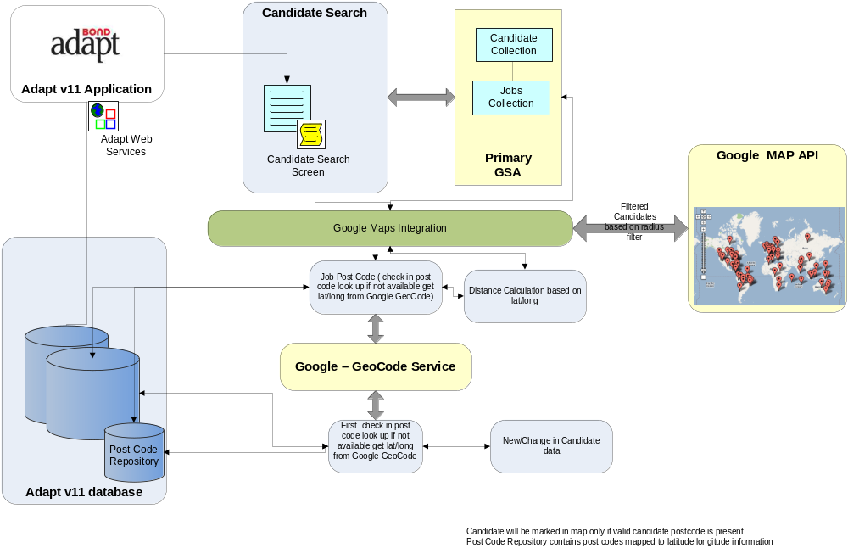

Organisation Hierarchy Service
This service will be used to link client hierarchy in Adapt by the consultants. The integration design details can be obtained from - http://hsrdk2k7sp1/haysit/pmo/adapt/InterfaceDesignBuild/Workstream%20Specific/Organisation%20Hierarchy/Adapt%20V11%20Organisation%20Hierarchy%20Interface%20Design%20V0%201.doc
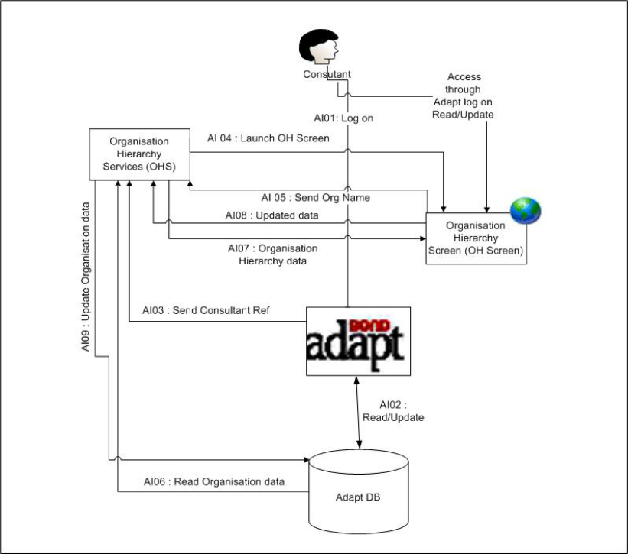

Document Management Integration (C65/C66)
Adapt system stores all candidate related compliance documents (e.g., passport, p45, education qualifications, etc…) within the built-in document library module that stores everything under the database with limited metadata. Adapt V11 supplied document library features were limited, the existing V8 document library was holding all scanned images and other candidate documents hence the file based database was growing exponentially which was causing performance issues and out of space errors. An architectural decision was taken to integrate both Adapt V8 and V11 systems with a document management system (DMS).

The initial plan was to integrate Adapt systems with Hays enterprise wide DMS chosen by Proveho. However the DMS vendor selection process and the delivery of Proveho DMS solution was not fit with the Adapt programme delivery hence a decision was taken to use Microsoft Windows SharePoint Services (WSS 3.0) as the DMS solution.

Adapt consultants will be able view, delete and upload new documents from Adapt V11 and V8 to the DMS solution using the document management service and custom web pages.

The details of this integration can be obtained from - http://hsrdk2k7sp1/haysit/pmo/adapt/InterfaceDesignBuild/Workstream%20Specific/DocumentManagement/Adapt%202010%20EDM%20Solution%20Architecture%20v0.4.doc

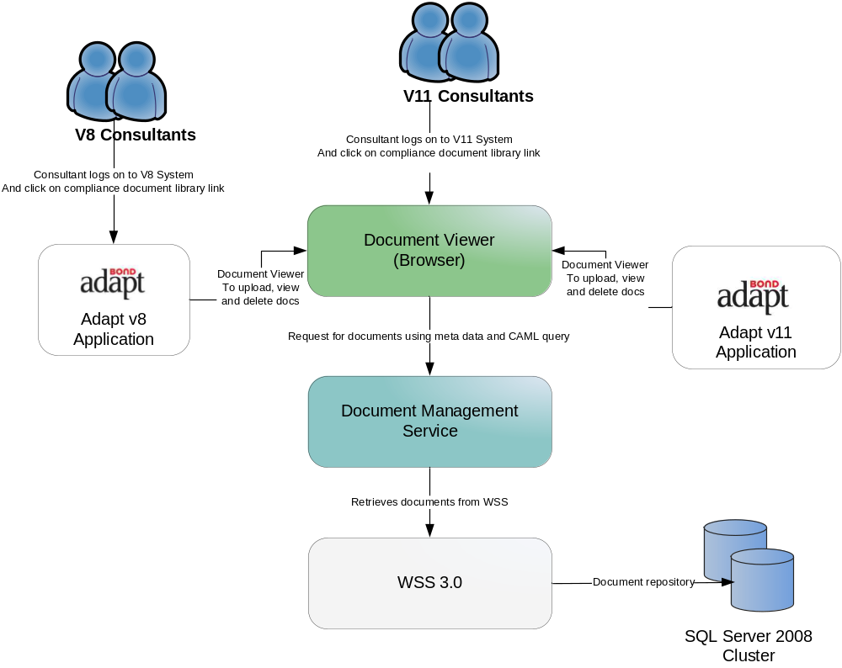

Web Uploader Service (C64)
OneTouch will make use of WebUploader service for:
- Publishing Job Advertisements on to hays.com
- Publishing Job Advertisements on to external job boards
- Publishing Candidate profiles on to Hays.com

For the purposes of Adapt 2010 programme, WebUploader is an external service. This service will simply be invoked from Adapt using the interface exposed by WebUploader and WebUploader will control the rest of the functionality. For UK, The Hays Web team owns this service. As part of localisation, individual countries may decide to implement their own version of WebUploader to target the local job boards. The design of WebUploader can be controlled locally, as long as the interface to the Global OneTouch system remains the same.

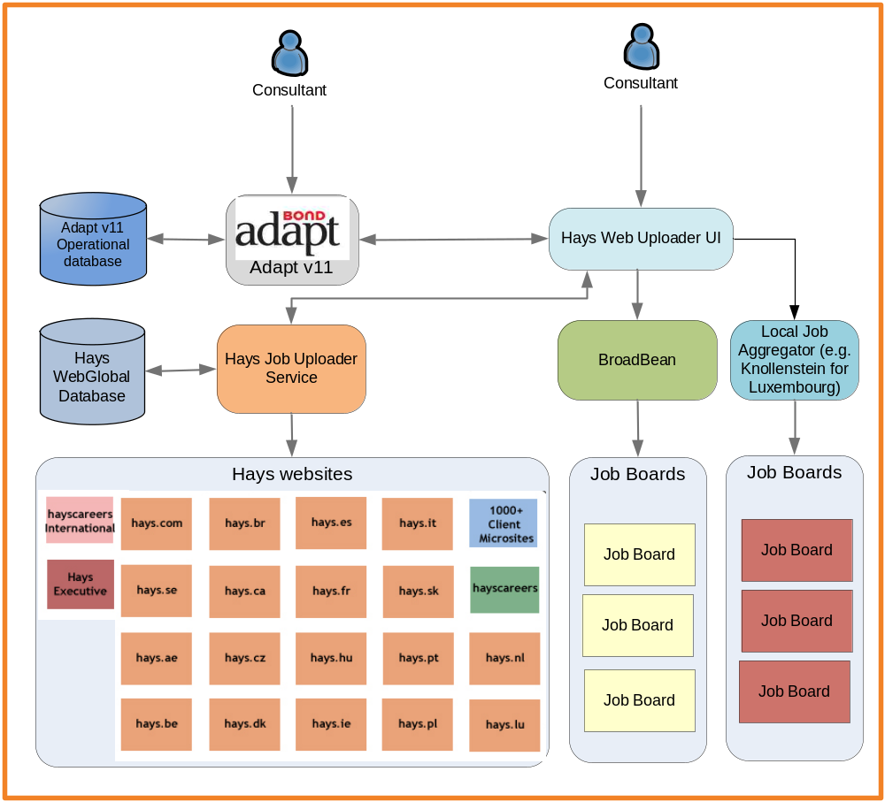

Operational Reporting Component (C62)
The operational reporting component leverages on Microsoft SQL Reporting Services (SSRS) as the reporting platform to report all Adapt related KPI’s. The current implementation of operational reporting use Adapt transactional database to report against for various KPIs by using custom built audit table mechanism through Adapt Business Objects. This implementation will change as soon as we have an operational database mart which will be populated by an overnight data extraction module built on top of SQL Server Integration Services (SSIS) to extract transactional data from Adapt database. The extracted data will be further used to create data dimensions and cubes using SQL Server Analysis Services (SSAS).

The existing operational reporting technical design is given below.

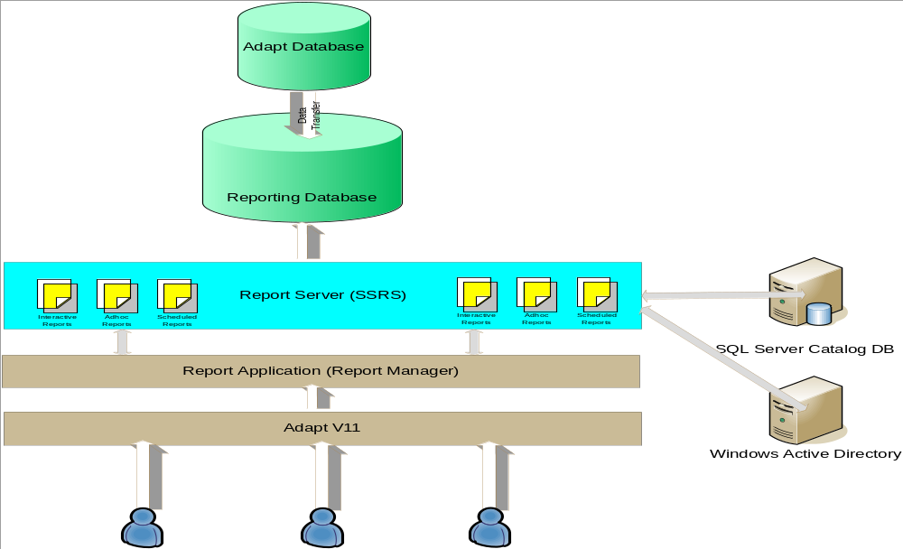

Contracts Portal Component (C62)
This component replaces a series of existing spreadsheets used for pricing matrix and contract agreements. This portal will be used by the bids and contracts team to create a contract with certain pricing structure for client based on job types so that Hays can offer an agreed structure for job placements rather than consultant drives the pricing decisions. This system integrates with Adapt as part of the placement process to choose the right pricing structure and client agreement details which will be sent to back office systems along with the placement.

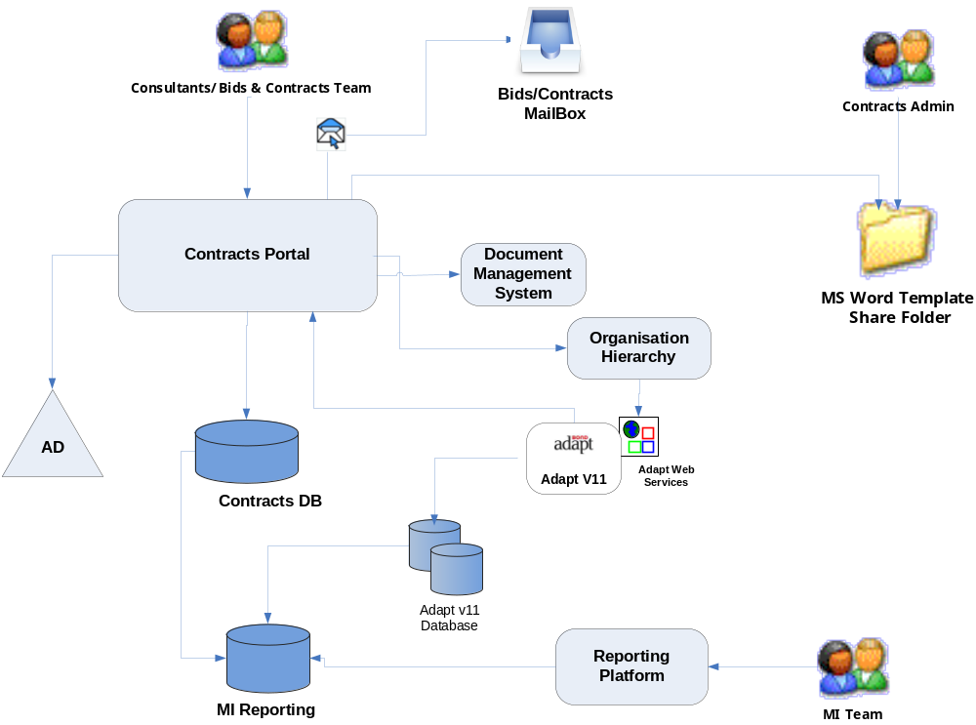

HPI Integration Component (C72)
Hays performance indicator component is responsible for providing satisfaction feedback survey from clients, candidates and contacts. This component uses an external service provider ConfirmIT to conduct survey from various participants and supply with different types of reports.

The intention of this integration is to get the raw feedback data from ConfirmIT and integrates with One Touch data warehouse to produce consolidated reports.

The first phase of this integration is to provide a CSV file format to ConfirmIT on a shared drive, which gets processed by the interface, and upload the survey results into reporting portal.

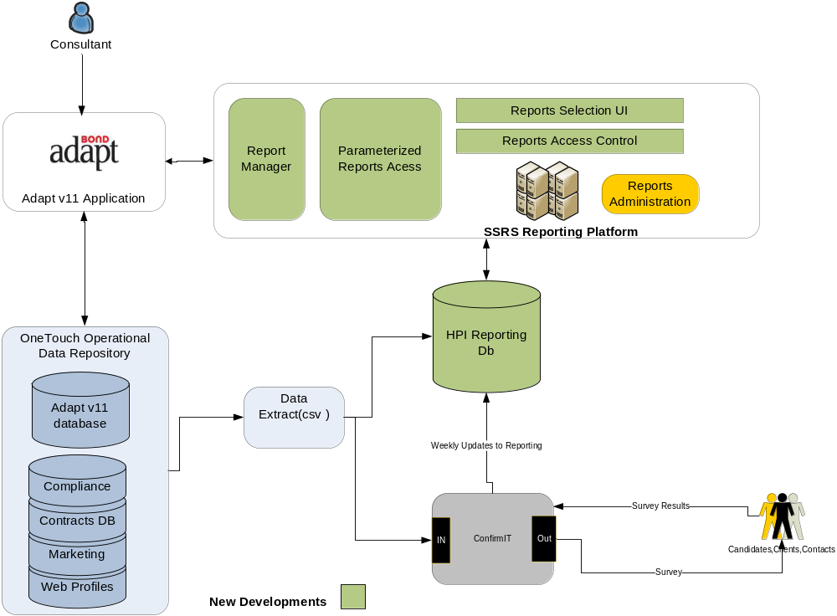

Candidate Registration Service
Details of this service can be found in Candidate Registration Technical Specification.

Infrastructure Architecture

Logical Deployment Model
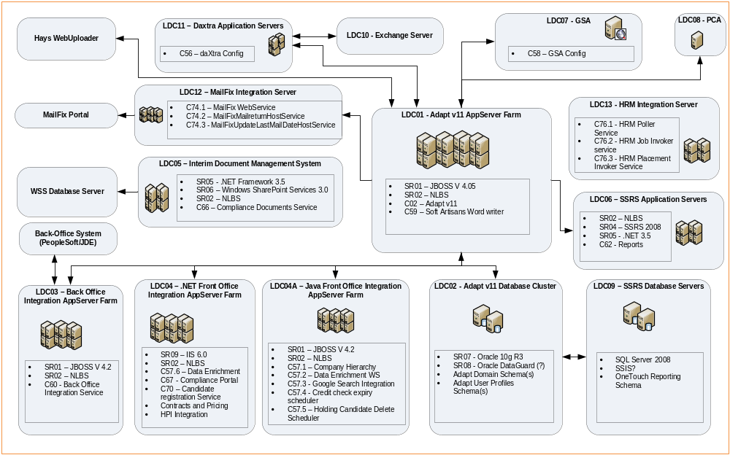

Logical Deployment Components List
Id | Description | Deployed OneTouch Software Components | System Requirements
Id | Description | Deployed OneTouch Software Components | Minimum Hardware Profile | Software
LDC01 | Adapt Application Server Farm | - C02 - Adapt v11 5.3 | AppServer Profile | - JBOSS v 4.05  - NLBS
LDC02 | Adapt Database Cluster | None | DB Profile | - Oracle 10g R2 Enterprise Edition  - Oracle Dataguard  - Oracle Parallel Partioning
LDC03 | Adapt Back office Integration Server Farm | - C60 – Back Office Integration Service | AppServer Profile | - JBOSS v 4.2  - NLBS
LDC04 | .NET Front Office Integration Server Farm | - C57.6 – Data Enrichment  - C67 - Compliance Portal  - C70 – Candidate registration Service  - C61 - Contracts and Pricing  - C72.1 - HPI Integration  - C77 – Fuzzy search | .Net AppServer Profile | - IIS 6.0  - NLBS
LDC04A | Java Front Office Integration Server Farm | - C57.1 – Company Hierarchy  - C57.2 – Data Enrichment WS  - C57.3 - Google Search Integration  - C57.4 - Credit check expiry scheduler  - C57.5 – Holding Candidate Delete Scheduler | Java AppServer Profile | - JBOSS v 4.2  - NLBS
LDC05 | Interim Document Management System | - C66 – Compliance Documents Service | WSS3 Profile | - .NET Framework 3.5  - Windows SharePoint Services 3.0  - NLBS  - IIS 6.0
LDC06 | Reporting Platform | - C62 – Reporting Platform & Reports | SSRS Profile | - NLBS  - SSRS 2008  - .NET 3.5  - SQL Server 2008 Enterprise Edition
LDC07 | Daxtra Application Server Farm | - C56 - Daxtra Accounts Configuration | Daxtra Profile | Daxtra Engine Version ?
LDC08 | Google Search Appliance | - C58 - Google Collections and associated configuration | N/A (3rd Party Appliance) | ?? GSA Software Version
LDC09 | Postcode Anywhere (PCA) | None | PCA Profile | PCA version number?
LDC10 | Adapt Database DR Cluster | None | DB Profile | - Oracle 10g R2 Enterprise Edition  - Oracle Dataguard  - Oracle Parallel Partioning
LDC11 | Exchange Server | - Daxtra Mailboxes | Exchange Profile | Microsoft Exchange Server 2003
LDC12 | Mailfix Integration Server | - C74.1 – MailFix WebService  - C74.2 – MailFixMailreturnHostService  - C74.3 – MailFixUpdateLastMailDateHostService | AppServer Profile
LDC13 | HRM Integration Server | - C76.1 - HRM Poller Service  - C76.2 - HRM Job Invoker service  - C76.3 - HRM Placement Invoker Service | AppServer Profile

Security

The OneTouch system will need to:

- Determine who sees what data (including clients and candidates)
- Determine who can do what in the system (including clients and candidates)
- Facilitate compliance with data protection requirements
- Control printing and emailing of the database
- Provide an audit trail of key activity within the database (e.g. changes to the data)
- Give visibility to key managers of consultant activity

The OneTouch security architecture needs to fit in with the overall security architecture for Hays, which is documented separately. However, due to a proprietary implementation of authorisation within Adapt v11, the core engine for OneTouch, it might not be feasible to adopt the Hays enterprise wide security model for OneTouch. Currently, OneTouch uses Adapt v11 provided authentication and authorisation mechanisms.

